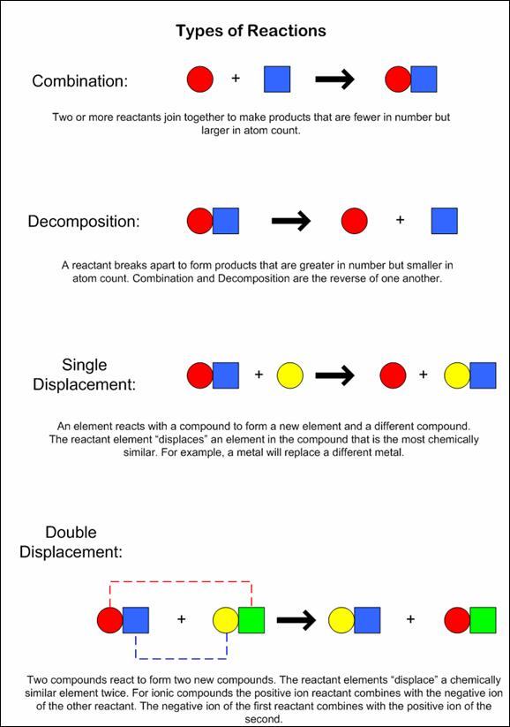
synthesis
replacement
replacement
If an organic compound is combined with oxygen and the products are CO₂ and H₂O….combustion

