The sinking of the Sleipner A offshore platform
Excerpted from a report of SINTEF, Civil and Environmental Engineering:
The Sleipner A platform produces oil and gas in the North Sea and is supported on the seabed at a water depth of 82 m. It is a Condeep type platform with a concrete gravity base structure consisting of 24 cells and with a total base area of 16 000 m². Four cells are elongated to shafts supporting the platform deck. The first concrete base structure for Sleipner A sprang a leak and sank under a controlled ballasting operation during preparation for deck mating in Gandsfjorden outside Stavanger, Norway on 23 August 1991.
Immediately after the accident, the owner of the platform, Statoil, a Norwegian oil company appointed an investigation group, and SINTEF was contracted to be the technical advisor for this group.
The investigation into the accident is described in 16 reports...
The conclusion of the investigation was that the loss was caused by a failure in a cell wall, resulting in a serious crack and a leakage that the pumps were not able to cope with. The wall failed as a result of a combination of a serious error in the finite element analysis and insufficient anchorage of the reinforcement in a critical zone.
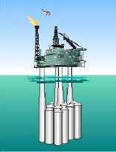
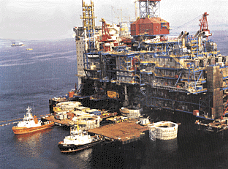
A better idea of what was involved can be obtained from this photo and sketch of the platform. The top deck weighs 57,000 tons, and provides accommodation for about 200 people and support for drilling equipment weighing about 40,000 tons. When the first model sank in August 1991, the crash caused a seismic event registering 3.0 on the Richter scale, and left nothing but a pile of debris at 220m of depth. The failure involved a total economic loss of about $700 million.
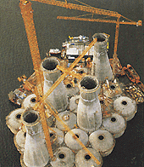
The 24 cells and 4 shafts referred to above are shown to the left while at the sea surface. The cells are 12m in diameter. The cell wall failure was traced to a tricell, a triangular concrete frame placed where the cells meet, as indicated in the diagram below. To the right of the diagram is pictured a portion of tricell undergoing failure testing.

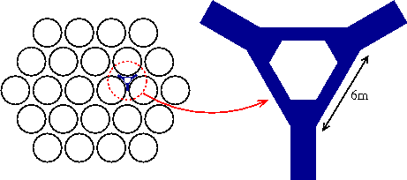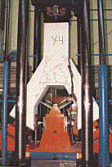
The post accident investigation traced the error to inaccurate finite element approximation of the linear elastic model of the tricell (using the popular finite element program NASTRAN). The shear stresses were underestimated by 47%, leading to insufficient design. In particular, certain concrete walls were not thick enough. More careful finite element analysis, made after the accident, predicted that failure would occur with this design at a depth of 62m, which matches well with the actual occurrence at 65m.
Further information can be found in a series of reports available for purchase from SINTEF and in the following articles:
- The Sleipner Platform Accident, by B. Jakobsen and F. Rosendahl, Structural Engineering International 4(3), August 1994, pp. 190-193.
- The Failure of an Offshore Platform, by R. G. Selby, F. J. Vecchio, and M. P. Collins, Concrete International 19(8), August 1997, pp. 28-35.

