The Chemistry of a Cheeseburger Last Name, First Name: _________________________________________________Unit #: _____ Date: ______ Period: _____
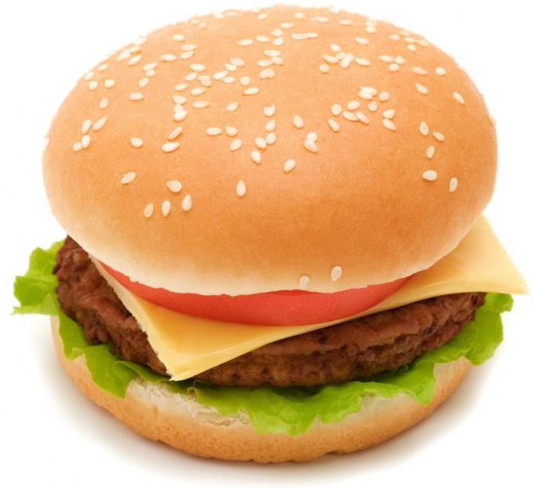
Objective: Students will learn about how chemical potential energy is stored in the food we eat using the real life example of a cheeseburger. Students will be able to describe how the energy in each component of a basic cheeseburger was obtained.
Bread:
What is flour?
What is a polysaccharide?
What is gluten?
What does yeast eat? What does it produce as a bi-product? What is the process of microbes converting sugar to gas (carbon dioxide) called? How does the dough become inflated (why does bread rise?)?

Cheese:
Is making cheese a chemical or physical rxn?
What is an emulsion?

What is denaturing? How is it done in making cheese?

How do they think making cheese was discovered?

Tomatoes
Draw the structure of ethylene:
What state of matter is ethylene in?
How does a tomato ripen?

The plant matter:
How do green plants get their energy?
What is chlorophyll? What color light does it absorb?

Why are green plants green?
Is photosynthesis and exothermic or endothermic reaction? Why?
The patty:

What is a protein?

What is meat composed of? What does it contain?

What does the red color in raw meat come from?
What type of reaction is cooking meat? (chemical or physical)
What do myoglobin proteins in the meat do when heated?

What is reaction that causes the browning called? Who is the chemist who discovered it?

