Unit: _____ Day 1-Inverse and Direct Proportions Last Name, First Name: _________________
Objective: Students will review proportional relationships (direct and inverse) in order to prepare them to learn about variables related to gases and how the vary proportionally with change.
- Minimum wage in HI is $7.75/hr. Plot salary vs. hours worked
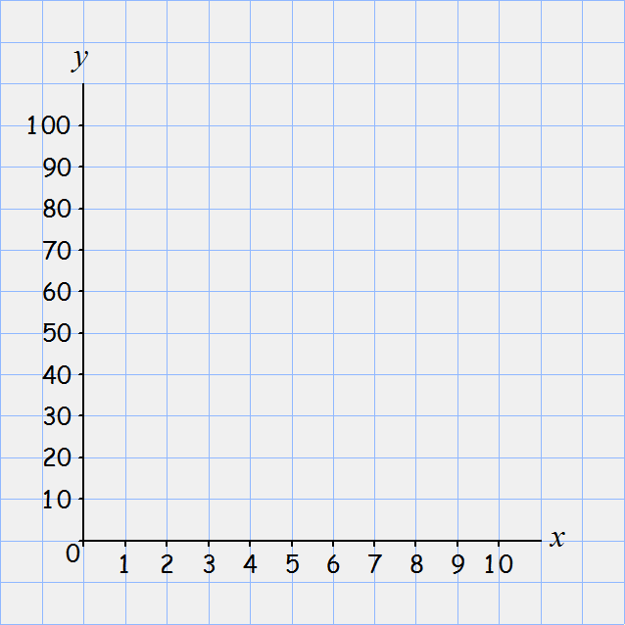

What relationship do we have?(What does it look like?) _____________
Besides that, it’s?
_____________
Give an equation to represent this situation:
Step 1: determine variables
w=
h=
Step 2: Prior Knowledge
How do you write the equation of a line in math?

Our Equation:

How is this equation different than our model equation?

Now what is the 7.75 in our equation called? __________
In general, in chemistry, we call this the __________ (constant of ________________________).
So we can say, K =

What is what k = the formula of? __________
This is a _________relationship. Another way to says this is that it is a direct ____________________.
Summary - Direct relationship (proportion):

Many jobs pay based on a salary. I make $48, 000 per year.
Step 1: How many working days are there in 1 year? 193 days
How many hours a day is the teacher contracted to work? 7 hours
“How much do I make in a day?” ________
How much do I make an hour if I work only the 7 hours?
___________________
In the space to the right, plot the amount I make per hour depending on how many hours I work in the day. (How much do I make per hour if I work 10 hours? 12 hours? Etc)

For a salary job, what happens to the amount I make per hour as a I work more hours in a day?
____________________________________________________
Write an equation for what you’ve shown on your graph:

To generalize in terms of x and y…our constant of proportionality, which for this case is ____ what is our equation?
Let’s compare dollars made per hour to hours worked
As hours worked increases, what happens to dollars made per hour? ___________
How? ________________
So for this type of relationship, if you increase one, what happens to the other? ___________
If you decrease one, what happens to the other? __________
What is one is increased by 2 times more? The other is __________.
One is 1/5 less….The other is? ___________
What is the name for this type of proportionality?__________
Write the 3 ways to represent inverse proportions:

Cats and Mice:

What’s the big picture here? If you keep ___ variable constant, you can look at the relationship between 2 variables in a multiple variable equation with __________ only. NOT for _________.
If we keep all other variables in an experiment constant so we can look at the relationship between 2 variables, what do we call that in science? ______________
Ok, now write one equation for cats, days, mice

Make a rule for an equation with all multiplication AND NO DIVISION so you can easily look at it and analyze which variables are directly related and which are inversely related:

Information: Gas Pressure

Figure 1: Two containers of gas molecules

Container 1 Container 2

Gas molecules move randomly in their containers, colliding with the walls of their containers causing “gas pressure.” Pressure can be defined as the force pushing on an area. It can be described with the equation:
where P is pressure (in kPa), F is force (in N) and A is area (in m²).

The more molecules collide with the wall and the faster the molecules are going when they strike the wall, the greater the force on the wall and therefore, the higher the pressure.

Critical Thinking Questions
- Use the pressure equation to explain why it would be more likely for an ice skater to fall through the ice on a lake than it would be for someone walking across the lake with regular shoes on.

- Which container in Figure 1 has the highest pressure? Explain.

- If I heated container 1 and did not heat container 2, could I get the pressure in container 1 to equal container 2? Explain.

- If container 2 was made of an elastic material and if I expanded container 2, could I make the two containers have equal gas pressures? Explain.

