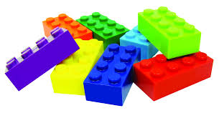

**Return of the Lego Atoms**

**Objective:**

SWBAT write balanced equations to describe chemical reactions.

1. In lego atoms, what did individual lego bricks represent? ______
2. 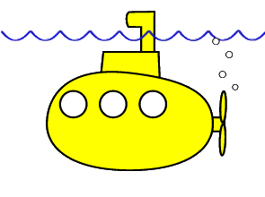An atom can be called a ________ (so can a molecule) because it functions as 1 unit.
3. What is used to represent the number of atoms in the molecule? _______________
4. When you connected the lego bricks, we said they were connected by what? __________ bond
   1. An _________ bond forms between _______ cations and ________ anions.
   2. A ___________ bond forms between ____________ and ___________.
   3. A ___________ bond forms between a metal and a metal.
5. The color scheme for the elements is:

Name that compound:

|  |  |
| --- | --- |
| Hydrogen | white |
| Carbon | Black |
| Nitrogen | Blue |
| Oxygen | Red |
| Fluorine and Chlorine | Green |
| Alkali Metals | yellow |
| Iron (Fe) | Gray/tan |

1. Please use the legos to represent the following chemical equation:

____ Na + ____ Cl2 = ___ NaCl

Please draw (IN COLOR!) the legos for this equation

|  |
| --- |
|  |

**The law of conservation of matter**, also known as the **conservation of mass**, states that the amount of matter in a closed system never changes. This appears on the surface to be wrong when someone looks at the simple issue of what happens to matter when burned on Earth. It would seem that the matter was destroyed to some degree in the process, and this was believed to be the case until the 18th century. If Earth were an entirely sealed system, the heat, light, [sound energy](http://www.wisegeek.org/what-is-sound-energy.htm), and escaping gasses generated in the burning process would still be detectable. Matter, therefore, can change form in a closed system, as can energy, but it can never be created or destroyed.

*☺ Read me, Please!*

1. Based on the light reading about The Law of Conservation of Matter…How do you think the law of conservation of matter will come in to play when balancing equations?

Does this change your answer to number 6?

1. Because the law of conservation of mass tells us that we cannot destroy or create matter, we need to have the same number of atoms on the left as the right. Instead of calling them the compounds on the left and the compounds on the right, in chemistry we call the reactants the chemicals who react together to form the products. For number 6, please draw circles around the lego particles which are reactants and draw squares around the lego particles which are products.
2. Please use the legos to balance the following equations:
   1. ____ Na + ____ H2O = ____NaOH + ____ H2

|  |
| --- |
| Stamp: |

* 1. ____CO + ____ NO = ____CO2  + ____N2

|  |
| --- |
| Stamp: |

* 1. _____Fe2O3 + _____CO = _____Fe + _____CO2

|  |
| --- |
| Stamp: |

1. For the lego particles, how could you determine the equations were balanced using the legos? (What did you do?)

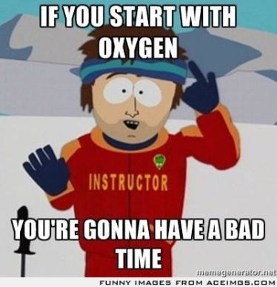

Some balancing tips…

A Balancing Act…

Let’s look at different methods of how to balance a chemical equation.

The Match-Up Method:

____CO + ____ NO = ____CO2  + ____N2

Steps:

1. Determine the number of each atom on C: C:

the left and right. N: N:

(Remember the subscript tells you how O: O:

many of that atom.)

1. To have the same number of each

atom on the left and the right, you

can ONLY change the __________. NEVER change the subscripts!!

Try the match-up method with your group!

|  |  |  |  |  |  |  |  |
| --- | --- | --- | --- | --- | --- | --- | --- |
| 1 | _____Fe | + | _____H2S04 | → | _____Fe2(SO4)3 | + | _____H2 |
|  |  |  |  |  |  |  |  |
| 2. | _____C2H6 | + | _____O2 | → | _____H2O | + | _____CO2 |
|  |  |  |  |  |  |  |  |
| 3. | _____KOH | + | _____H3PO4 | → | _____K3PO4 | + | ____H2O |
|  |  |  |  |  |  |  |  |
| 4. | _____SnO2 | + | _____H2 | → | _____Sn | + | _____H2O |
|  |  |  |  |  |  |  |  |
| 5. | _____NH3 | + | _____O2 | → | _____NO | + | _____H2O |

Balance the following equations:

|  |  |  |  |  |  |  |  |  |  |  |  |  |  |  |  |  |  |  |  |  |
| --- | --- | --- | --- | --- | --- | --- | --- | --- | --- | --- | --- | --- | --- | --- | --- | --- | --- | --- | --- | --- |
| 6. | _____KNO3 | | | + | | | _____H2CO3 | | | → | | | | | _____K2CO3 | | | + | _____HNO3 | |
| 7. | _____B2Br6 | | | + | | | _____HNO3 | | | → | | | | | _____B(NO3)3 | | | + | _____HBr | |
| 8. | _____BF3 | | | + | | | _____Li2SO3 | | | → | | | | | _____B2(SO3)3 | | | + | _____LiF | |
| 9. | _____(NH4)3PO4 | | | + | | | _____Pb(NO3)4 | | | → | | | | | _____Pb3(PO4)4 | | | + | _____NH4NO3 | |
| 10. | _____SeCl6 | | | + | | | _____O2 | | | → | | | | | _____SeO2 | | | + | _____Cl2 | |
| 11 | | _____CH4 | | | + | | | _____O2 | | | → | | _____CO2 | | | + | _____H2O | | |  |
| 12 | | _____Na+ | | | + | | | | _____Cl- | | → | | _____NaCl | | |  | | | | |
| 13 | | _____Al | | | + | | | | _____O2 | | → | | _____Al2O3 | | |  | | | | |
| 14 | | _____N2 | | | + | | | | _____H2 | | → | | _____NH3 | | |  | | | | |
| 15. | | | _____CO(g) | | | + | | _____H2(g) | | | | → | | _____C8H18(l) | | + | _____H2O | | | |
| 16. | | | _____FeO3(s) | | | + | | _____CO(g) | | | | → | | _____Fe(l) | | + | _____CO2(g) | | | |
| 17. | | | _____H2SO4 | | | + | | _____Pb(OH)4 | | | | → | | _____Pb(SO4)2 | | + | _____H2O | | | |
| 18 | | | _____Al | | | + | | _____HCl | | | | → | | _____AlCl3 | | + | _____H2 | | | |
| 19. | | | _____Ca3(PO4)2 | | | + | | _____H2SO4 | | | | → | | _____CaSO4 | | + | _____Ca(H2PO4)2 | | | |
| 20 | | | _____H3PO4 | | | + | | _____HCl | | | | → | | _____PCl5 | | + | _____H2O | | | |