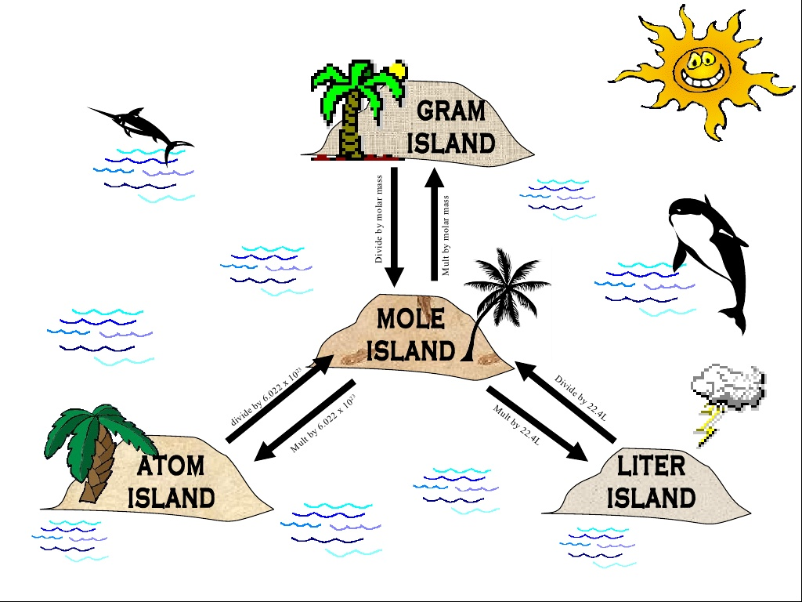
All Passages Lead through Mole Island!
Island Hopping with Chemistry Units
Objective: Students will write the conversion factors to go between the islands to use as a reference when converting between units in chemistry.
STOICHIOMETRY ROAD MAP

