Let’s Bond!
Objective: Students will be able to predict the number of bonds which will form based and based on electronegativity difference, show the relative locations of electrons in those bonds and determine relative strength of bonds and intermolecular forces.

A bond between Phosphorous and Chlorine:
Step 1: How many valenece electrons does each have? P: ____ Cl: ____ Draw the lewis dot structure for each:

Step 2: How many electrons are single? P: ___ Cl: _____

Step 3: How many bonds* can Phosphorous make? ___ How many bonds can Chlorine make? ____
*The number of bonds an element can make is determined by how many single electrons it has.

Step 4: Draw the Lewis Dot Structure (diagram) of the molecule:

A bond between Hydrogen and Chlorine: A bond between Hydrogen and Fluroine
Step 1: Step 1:
Step 2: Step 2:
Step3: Step 3:
Step4: Step 4:

Step 5: Which is more electronegative? _____ Step 5:
Step 6: Using your notes, draw the direction of Step 6:
the arrows on your Lewis dot diagram to show
which attracts electrons more.
Step 7: Use the delta sign to show + and - ends Step 7:

Is there a pattern between the number of single electrons available to participate in a bond and the number of bonds an atom will form? (Hint: a single lone electron will form a bond with a single lone electron from another atom.)

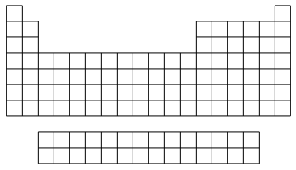
Predict the number of bonds that will form based on group number:
Group 1: Group 2: Group 13:
Group 14: Group 15: Group 16:
Group 17:

Explain why water has a high surface tension. (Why do water molecules want to stick together. Draw what is occurring at the particle level at the surface of water.

