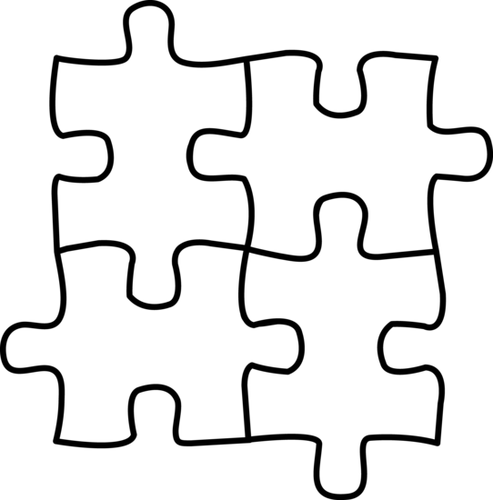
ION PUZZLES
- How did you and your partner decide to arrange your puzzle pieces to make little puzzles? Can have multiple puzzles. (In COMPLETE SENTECES, please )

- What made you decide arrange them this way?

- Please complete the table below using your knowledge from unit 2:
 | # protons | # electrons | Protons + (-electrons) | Charge | Ion symbol
Hydrogen Ion
Beryllium Ion
Chloride

- For each ion puzzle you made, draw the puzzle and please write the chemical formula. Let’s do the first one together.
^{Puzzle Pieces} | ^{Chemical Formula}

- For each ion puzzle, please determine which type of bond would form between the two ions.

- For each of the ionic compounds, you’ve just made, please write the name.
Naming ionic compounds, write the cation’s name first (as it appears on the periodic table) and the anion name goes second.

- Is there a pattern in the names of the cations? If so, what is the pattern?

- Is there a pattern in the names of the anions? If so, what is the pattern?

- Looking at the ions by group they belong to, on the periodic table, do you see a pattern in the ions each group forms?
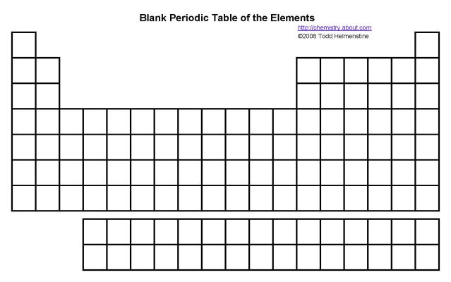

Group # | Charge of ion formed
1
2
17
18

- Which types of elements form ionic bonds, creating ionic compounds?

- Rules for naming ionic compounds:

- Another way to determine the subscripts for ionic compounds:
Making + equal to –

- Transition metal ions:
What makes ions formed by transition metals different?

