Step 1: Go to Blogger from your gmail.
To do this, click on the apps button

Click on more

Select even more from Google

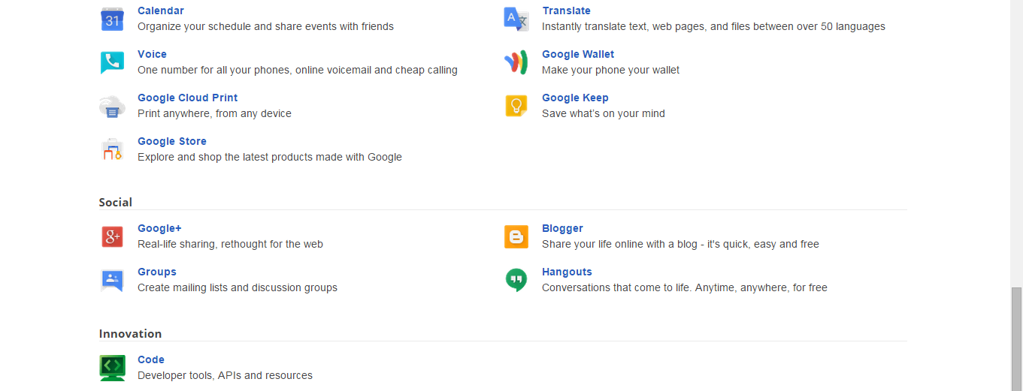
Step 2: Click on the Blogger button

Step 3: (see next page)
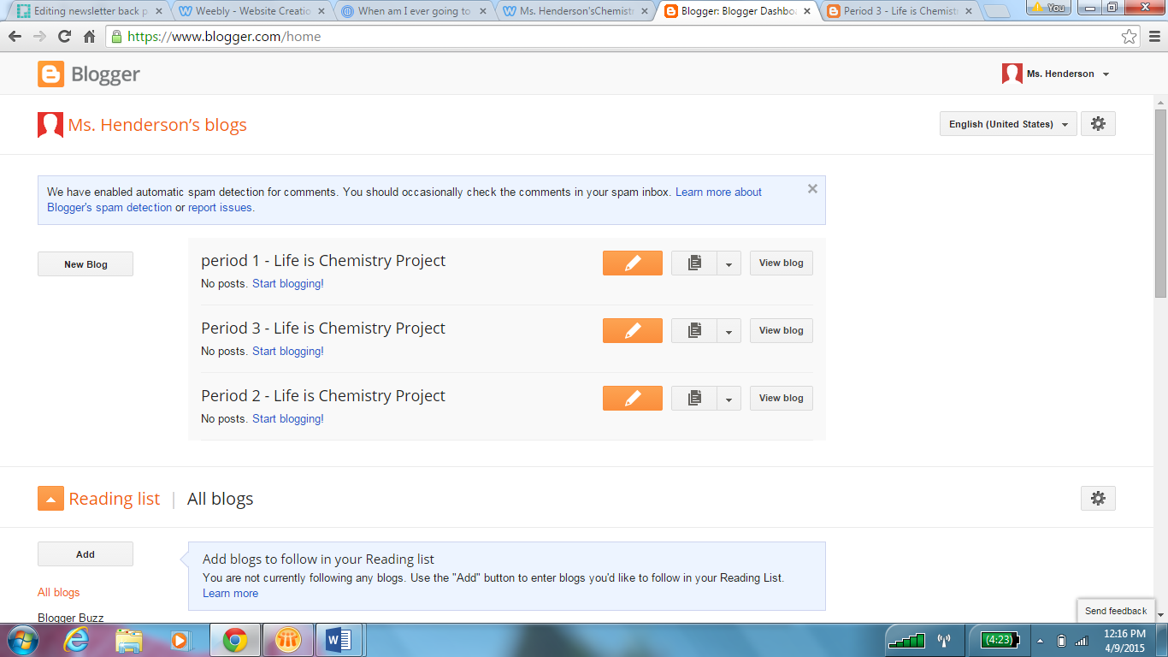
You are only an author on your period’s blog.
Click on the organe button (the pen icon)

This will allow you to create a post on our blog. Please see the rubric and the prezi for exactly what needs to be in your post.

