I’m ready to post my infographic….Now what?
Step 1: Click on download
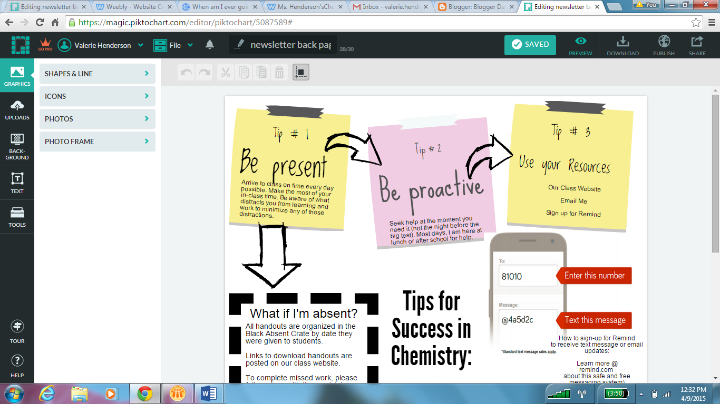
Step 2: It will now save to your computer as an image.
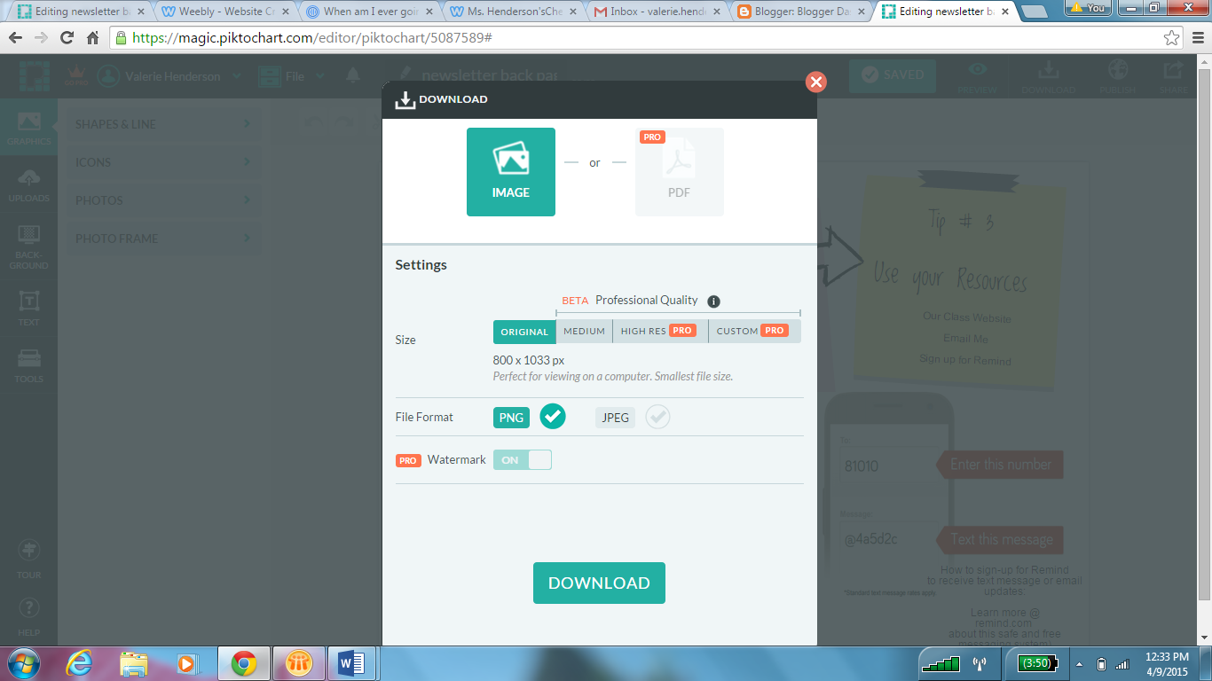

Step 3: In Settings, select medium
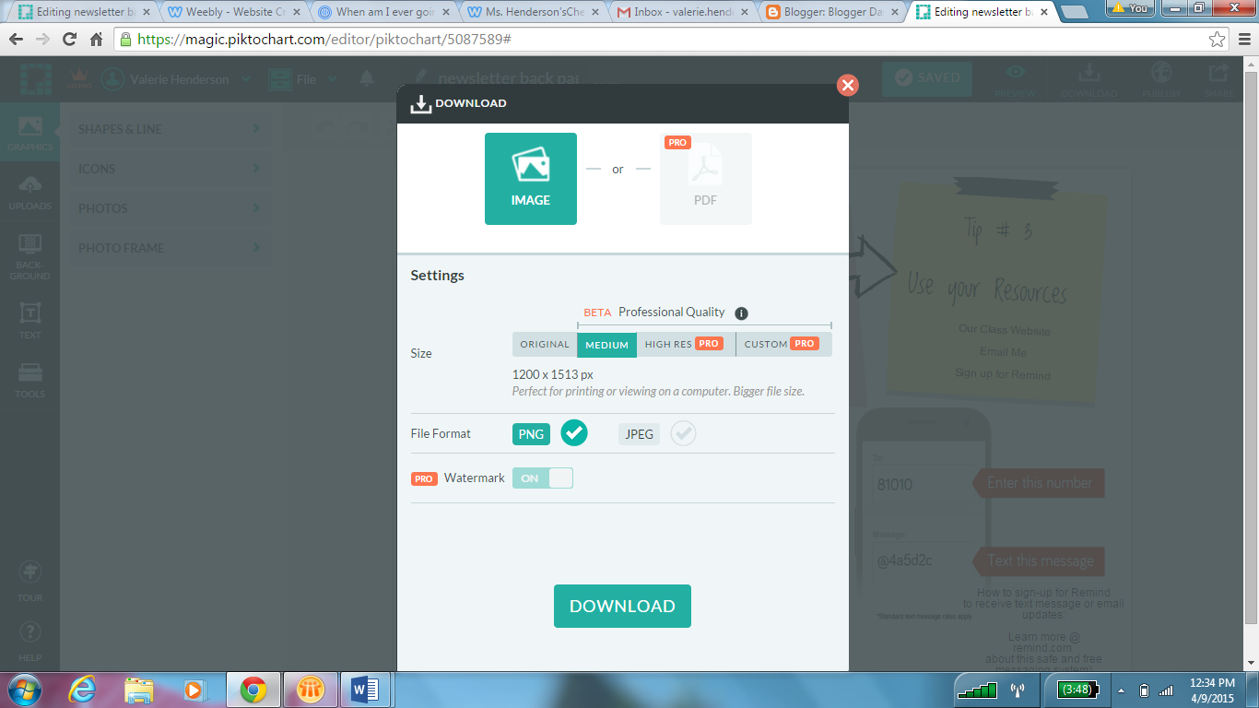
Then, click download. It will save in your download’s folder.
Step 4: Go to your period’s blogger dashboard. (see other instructions)
Step 5: Click, New Post

Step 6: Insert Image (Your Infographic)
You downloaded your infographic as an image. Select insert image and select the from your computer option. The image should have downloaded into your downloads folder.
Click on choose files
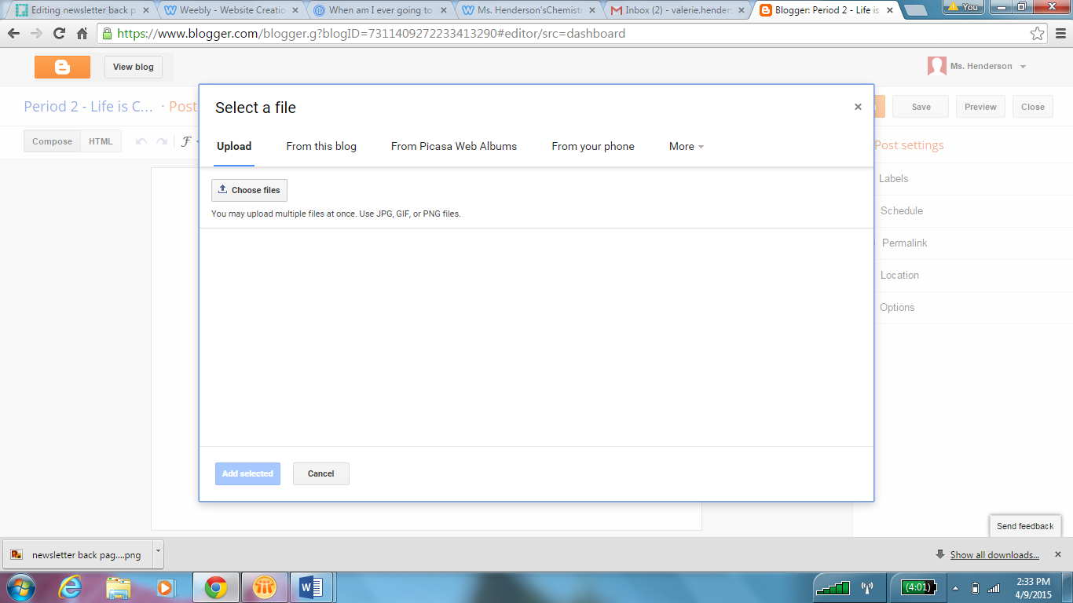
On the left side, click on the folder that says downloads.
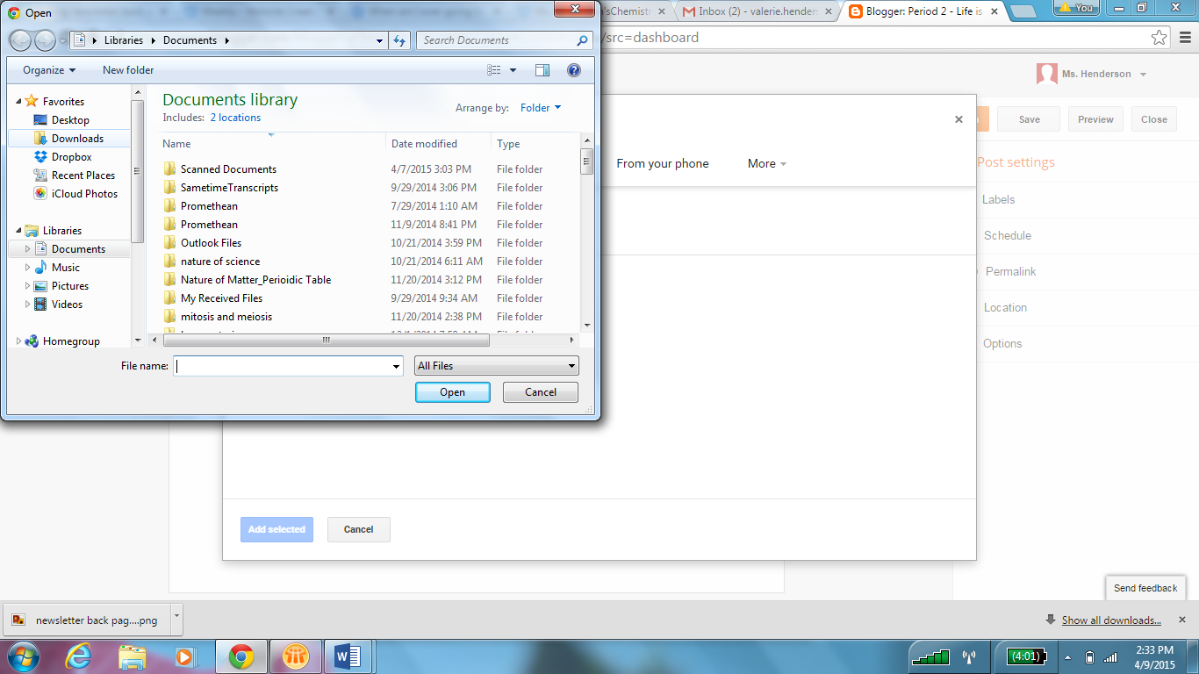
Find your infographic and click open. Then, click add selected.
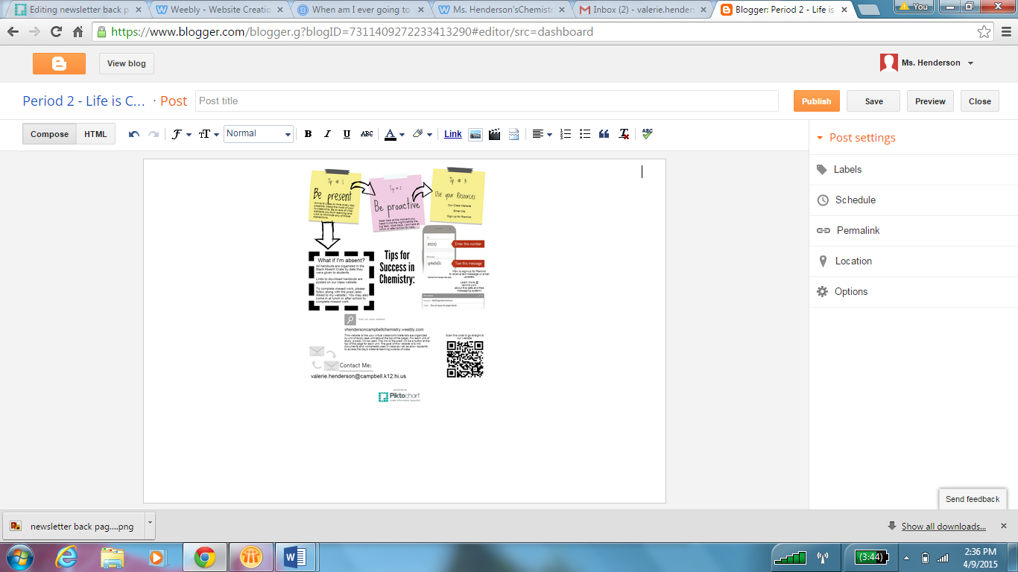
This is just an example of how to post to the blog, so you should see your infographic in this space.
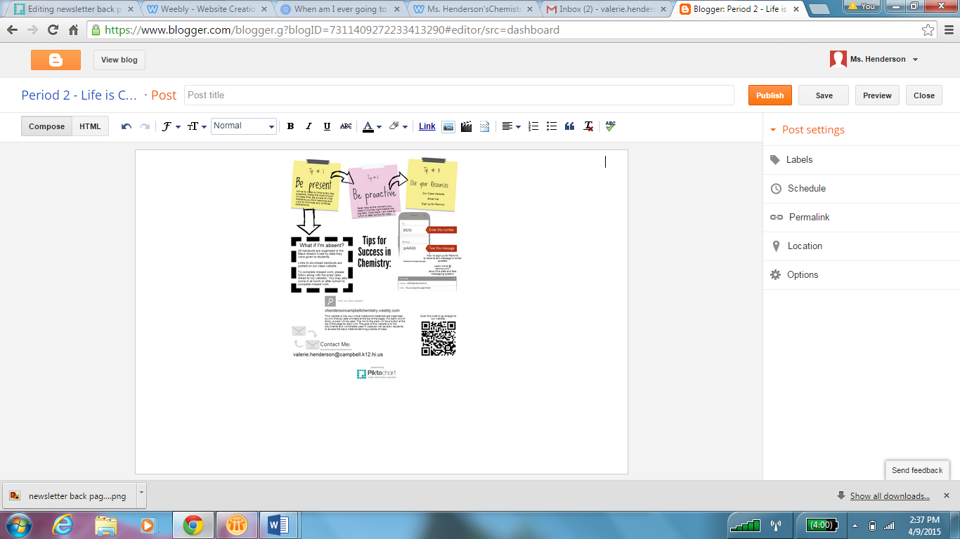
Just click publish when you’re happy with your post.

Congratulations, you’ve submitted your project! Good Work!

