Last Name, First Name: ___________________________________ Date: _____________ Period: ____
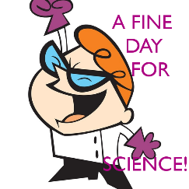
How to do the Science
Pre-video clip:
What is science? – Draw it!
What does science mean to you?

What science is not: | What science is:

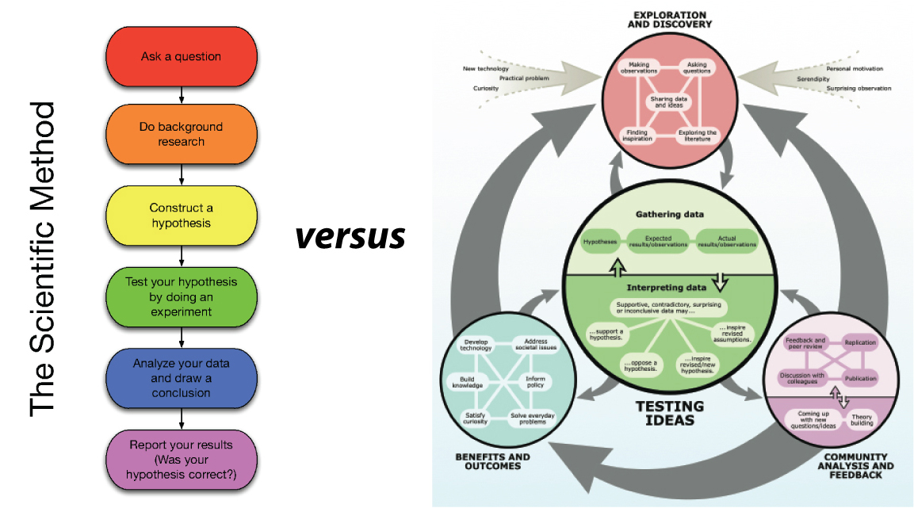
Draw arrows to answer the questions:

Which is the chart you learned about the “scientific method?”

Which is the correct chart to represent science?

http://undsci.berkeley.edu/article/scienceflowchart
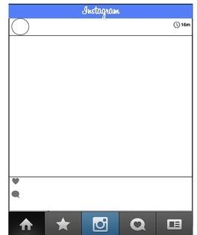
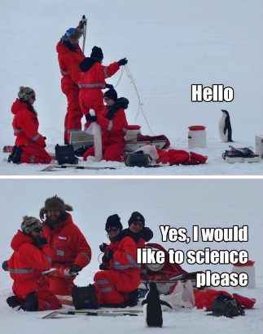
InstaScience!

To the left, make an Instagram
that represents what science is
to you after watching the video
and completing the top portion
of this handout.

What is different about this compared to what you drew for the warm-up?

Questions
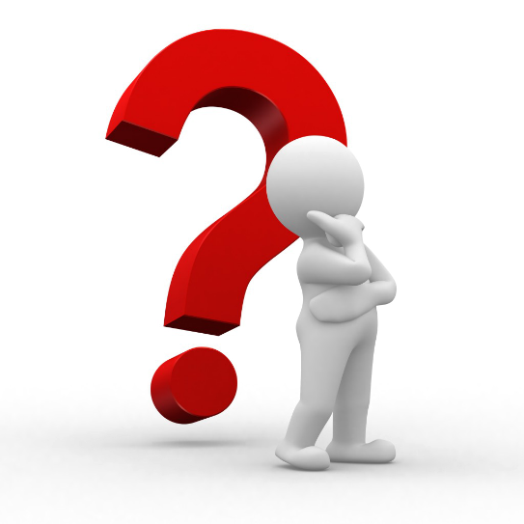
Types of Questions: Characteristics

- _______________________

- _______________________

- _______________________

1. Will there be a full moon tonight?
2. Why is it important that the desert plants get rain in spring?
3. Why is the desert hot?
4. What is the significance of red sky at nightfall?
5. Why does lightening come before thunder?
6. How can the time delay between lightening and thunder be used to tell how far away a storm is?
7. Can stars be red?
8. If salt is added to water, will the water boil at a different temperature?

A question of science must be __________________.

What makes something testable?

*Remembering from our gas laws and calorimetry learning…in order to

study the relationship between 2 variables, what must we do to all other variables?

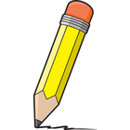
Now it’s your turn to write a testable question.
Testable Question Checklist:
- It has an answer and can be tested.
- It can be tested by an experiment you can do or a measurement you can make.
- It builds on what you already know.
- When answered, it leads to other questions.
