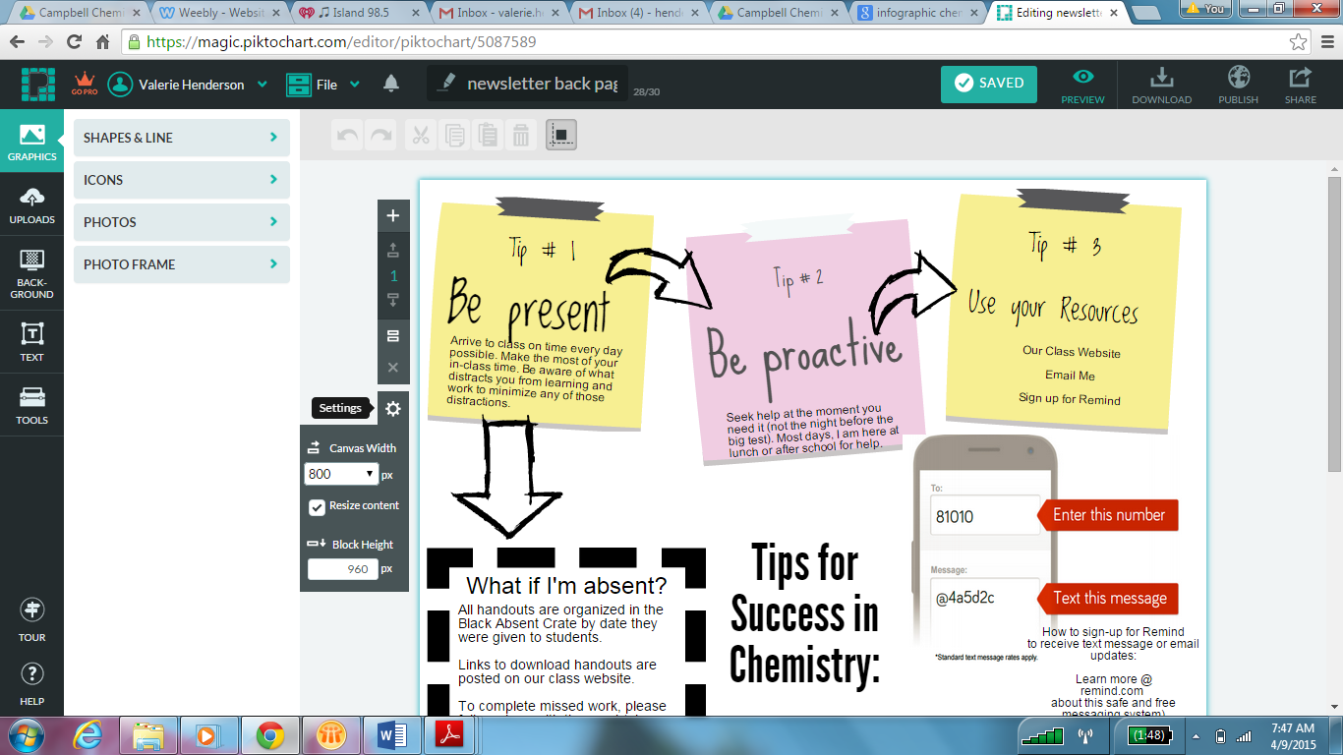
Step 1: Delete any extra blocks so only one bloc is present.
Step 2: Change the block pixel sixe. Press the settings button (You have to click on the block to see this menu on the left.
Step3: The canvas width should be 800 pixels and the canvas height should be 960 pixels
Step 4: Start making your infographic!

