Last Name, First Name: _______________________________________________ Date: __________ Period: ___
Breaking down Bonding
Objective: Students will learn about chemical potential energy, types of bonds and types of intermolecular forces and how they relate to each other and energy in chemistry.
Essential Questions: _______________________________________________________________________________________
_________________________________________________________________________________________________________________
_________________________________________________________________________________________________________________
_________________________________________________________________________________________________________________
________________________________________________________________________________________________________________
Thinking Side: Main Notes:

What is energy?
Types of Energy
Kinetic:
Potential:

Forms of Energy:
Can you name things that release chemical potential energy and the reaction that releases that energy?

Chemical Bonds:
What holds compounds together?
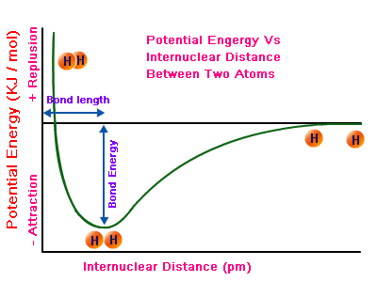 Bond Length:
Bond Energy:
In a covalent bond, are electrons taken or shared?
What does electronegativity mean?

Which electrons participate in bonding?

Chemical Potential:

Individual atoms have relatively low stability ( _______ gases are the only exception). Individual atoms become more stable when part of a _____________.

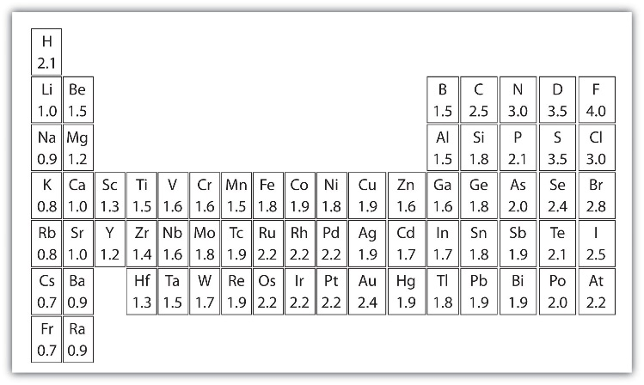

valence electrons are ___________________________
Nonpolar covalent:
Draw bonding of H₂

What do you think happens when the electronegativities are not the same?
Draw the Lewis dot for C and O

Which has a higher electronegativity?
Which one wants the electrons more?
Polar Covalent Bond:
Draw the polar covalent bond

Why is there are partial (-) charge?

Polar Molecules
What does the word polar mean?
Draw the water molecule shown:

Dipole:
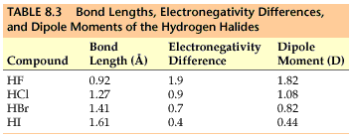
Would a greater electronegativity difference be associated with a stronger or weaker bond?

Bringing back Bonding:
Draw the Lewis dot structure for O and H:

How many H atoms will bond with 1 O?

Carbon dioxide vs Water
Draw the CO₂ and H₂O molec.

Valence electrons are ______________________________

Bond energy (KJ/mol) *bond energy =

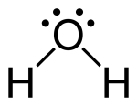

Carbon dioxide is ____________________ (doesn’t have a dipole), the attractive force between carbon dioxide molecules is ______________.
The attractive force between water molecules is ____________ because of the ___________ (partial positive and partial negative charges), attractive force btwn. water molecules is _____________.
Single bond
Draw:

Double bond
Draw:

Triple bond
Draw:

Intermolecular Forces:

Dipole-Dipole:

London Dispersion:

