Unit 3: Dot, Dot…Lewis Dot Last Name, First Name: __________________________________
The electrons in the highest energy level (_____most energy level) are called ____________ electrons. Valence electrons are always in the highest energy level. These are the electrons that participate in forming _________ bonds.
I Do: Draw the Bohr diagram for Hydrogen:
How many electrons are in the highest energy level? ___
How many valence electrons does Hydrogen have? ____
Draw the Lewis dot structure for Hydrogen

We Do: Draw the Bohr diagram for Helium:
How many electrons are in the highest energy level? ____
How many valence electrons does Helium have? _____
Draw the Lewis dot structure for Helium

You Do: With your table group…
Draw the Bohr diagram for Lithium:
How many electrons does are in the highest energy level? ____
How many valence electrons does Lithium have? _____
Draw the Lewis dot structure for Lithium

Draw the Bohr diagram for Beryllium:
Draw the Lewis dot structure for Beryllium:

Independent Practice:
Look at the Lewis dot diagrams for the following elements. Label each with the group number.
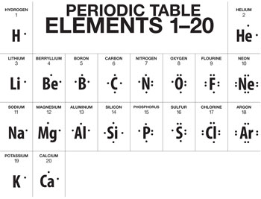
- Do you notice a pattern in the valence electron numbers of these atoms? YES NO
Please describe a pattern if you see one:

- Please complete the table below for valence electron number for each periodic table group of the representative elements.
An atom will gain or lose electrons to get to a full octet. A full octet is 8 valence electrons.
For the metals (groups 1 and 2) would they gain or lose electrons to get to a full octet?
______
Groups 16 and 17? ______
Group Number | Valence e⁻
1
2
13
14
15
16
17
18
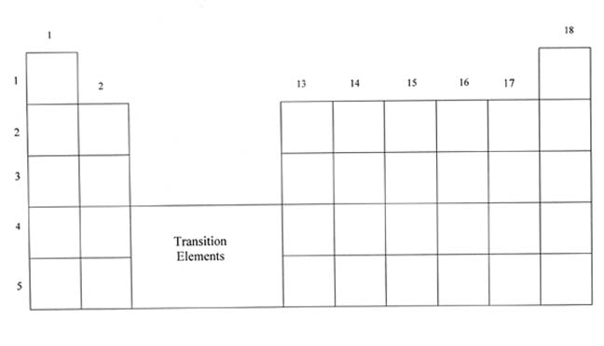
When an atom loses electrons (think metals giving up electrons to have a full octet) what kind of ion is formed? ___________
Nonmetals gain e- to have a full octet? (ion type) __________
On the periodic table to the right, please write the charges of the ions each of the representative groups form.

