Chemistry Conceptual Exam Concepts (Study Guide for final on 5/19) Name: _________
Unit 1: Science, Matter and Measurement
3 Key Ideas: 1. Learning the Metric System...we’re different
2. Learning about graphs...wonder why? ;)
3. Learning the math...math level now = wizard
 | mass | number of particles | Temperature | Volume
SI Unit:

The 4 states of matter (from lowest to highest energy: _________________________________________________
In an experiment, what is a control group?

when to use what type of graph:
Graph reading/interpretation/proper useage
choices to put in boxes =
- shows trends across an entire data set,
- show parts (categories) compared to a whole (the whole = 100),
- shows a side by side comparison of data
Bar Graph | Line Graph | Pie Chart

Place value/multiplying/dividing by 10s without a calculator (because you’re that awesome!)
List the place values vertically below each number: 1,234

No using your calculator! What is 1 x 100 = 123 x 1,000 = 12/10 =

As you move to the left through a number (example, for 1,234, going from the 3 to the 4) does the place value increase or decrease? _____________ By how much? (how many times greater?) ______
How many grams are there in 1 kilogram?
Which would you measure and elephant in? grams kilograms ounces
Big Numbers: Please write this number in scientific notation: 2, 000 _________________________
000.2 _________________________
What is scientific notation for? (what is the purpose, why would we use it?)

Unit 2: Matter and the Periodic Table
3 Key Ideas: 1. Learning about the types of matter and how it is classified.
2. Learning about how the periodic table is organized (by atomic #)
3. Learning about periodic table trends
For each, write the characteristics that distinguish it from the other types of matter:
atom | molecule | compound | mixture
Heterogenous mixture: _____________________________________________________________________________________
Homogenous mixture: ______________________________________________________________________________________
Distinguish between the two and give an example of each:
Chemical Separation | Physical Separation
For the periodic table, label the group numbers. Give the names for group 1,2,18
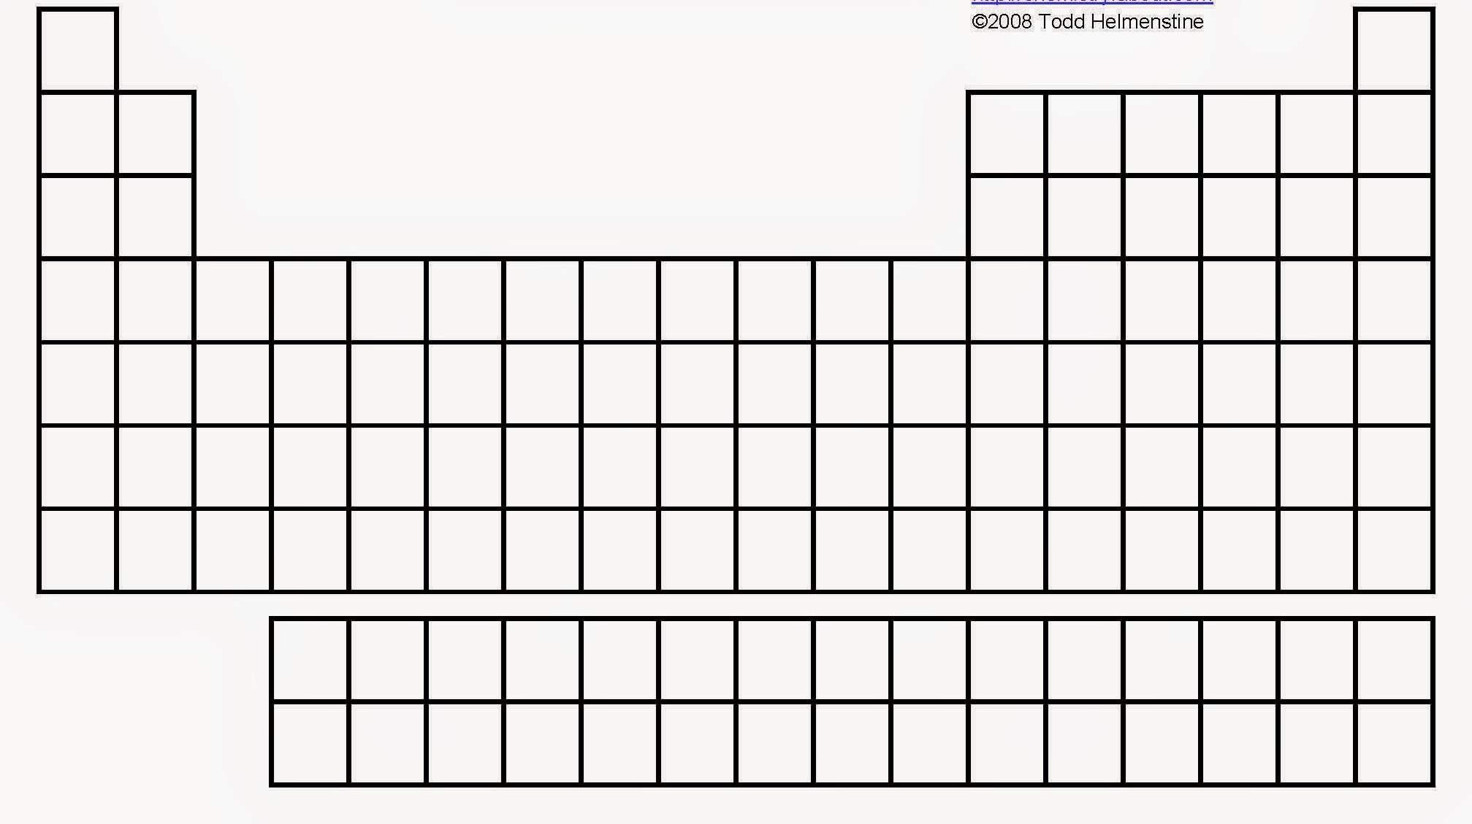
Which side of the periodic table are the metals? _________________ nonmetals? ____________________
Which group contains non-reactive elements that have a full octet (or duet for He)? ___________
For funsies, what is the element that is named after Ms. Henderson’s hometown? ___________________

What are the 3 subatomic particles and their charges: __________________________________________________
Where is most of the mass of an atom located? inside the nucleus outside the nucleus
Which subatomic particle changes the atom’s identity? _____________ Which participates in bonding? _________________ Which particle is different in an isotope? ________________ What does electronegativity mean? ___________________________________________________________________________________
Atoms with loosley held electrons are usually classified as metals. They will exhibit high conductivity, ductility, and malleability because of their atomic structure. Would you expect metals to have high ionization energies or low ionization energies? Explain your answer in 1-2 complete sentences.

Unit 3: Bonding with Names
3 Key Ideas: 1. Learning about models of atoms and the information they show.
2. Learning about ions.
3. Learning about different types of chemical bonds.
What does a Lewis dot diagram show? _____________________ Which electrons participate in chemical bonds? _____________________Why is being able to quickly see the number of valence electrons important? _______________________________________________________________________________________
What is an ion? __________________________ What are the charges of the ions for groups 1, 2, 13, 15, 16, 17. Do elements in group 18 form ions? (why or why not?) ____________________________________________
Is there a pattern in the names of cations?
Is there a pattern in the names of anions?
When ions come together to form compounds, what is the charge of the compound? _______________
Please complete the table with characteristics of each type of bond:
Ionic | Covalent | Metallic

What does the word polyatomic oxyanion mean? (hint: break it down now)

(Quiz 3.1) What is the the similarity between the Bohr model and the planetary model. What are the differences?

Unit 4: Balancing Moles
3 Key Ideas: 1. Learning about different types of chemical reactions.
2. Learning about the importance of balanced equations
3. Learning about the mole as unit to count numbers of atoms/particles
What is used to represent the number of atoms in a molecule? ______________________________
Why is it useful to have a mole as a unit? _________________________________________________________________
________________________________________________________________________________________________________________
Which is the smaller unit, grams (g) or atomic mass unit (amu)? _____________________________________
On the periodic table, when looking up the mass of 1 atom, what unit is the mass in?
“ “ 1 mole, what unit is the mass in?
Reactions of Our Lives:
List and give an example of the 5 types of chemical reactions (use the colored types of reactions (with the colored circles and triangles) and give a real life example

Unit 5: A Chemist’s Favorite Tree (Stoichiometry)
3 Key Ideas: 1. Learning about the importance of dimensional analysis for problem-solving.
2. Learning about the importance of significant figures.
3. Learning how the importance of chemical stoichiometry.
How many significant figures are in: 1,234 0.456 450. 1000.0
Why is it important to report proper significant figures in your calculations?

Why is it important to be able to convert from grams (g) of a chemical to moles (mol) of a chemcial? (Do we have a mol-o-meter to measure moles in lab?)

Why is it important to be able to calculate percent composition of a substance?

What is a limiting reactant?

Give one real-life example of a need for chemical stoichiometry:

Unit 6: Gases and Pressure
3 Key Ideas: 1. Learning about proportions.
2. Learning that nothing sucks.
3. Learning about real life examples of gases and pressure
What are the 4 postulates of kinetic molecular theory(KMT)? (KMT foldable)
1.

2.

3.

4.

Why is it important to understand KMT?

What causes gas pressure?

How is gas pressure increased?

In order to study the relationship between 2 variables, what must you do to all other variables?

Explain what nothing sucks means:

Explain why a bag of chips expands and sometimes pops when you drive up a mountain (increase altitude:

Explain why your ears hurt when you dive deep underwater until you clear them:

Unit 7: Energy
3 Key Ideas: 1. Learning about chemical bonds and their relation to energy.
2. Learning what energy is and how it measured.
3. Learning about energy transfer.
One interesting I learned about the chemistry of a chesseburger is: ___________________________________
________________________________________________________________________________________________________________
________________________________________________________________________________________________________________
What type of energy is stored in chemical bonds? ________________________________________________
What is energy? _____________________________________________________________________________________________
What is a polar molecule? _________________________________________________________________________________
What is the 1st Law of Thermodynamics: ________________________________________________________________
What is the difference between heat and temperature?

What does specific heat capacity mean?

What is an important assumption that is made in calorimetry calculations? What is the limitation of our mathematical model of calorimetry (basically what I mean here, is we assume certain things are true/happening in our lab but maybe they aren’t true….aka what went wrong?)

The calories we calculated in lab are not the same as the Calories on the nutrition facts. Why? (hint: lowercase c vs C in calories)

Unit 8: Acids and Bases
3 Key Ideas: 1. Learning about acids and bases.
2. Learning how acids and bases are used in life.
3. Learning about ocean acidification (the other carbon sink).
Compare and contrast acids and bases.

What happens when you mix an acid and a base?

Why are bases often used as household cleaners?

List chemicals you should never mix!

What is ocean acidification? Draw it at the particle level. What is its effect on marine shellfish?

