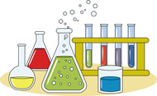
Last Name, First Name: _________________________________
Date(s): _______________ Period: ___
Chemistry is Life Project Presentations Notes
Standard Assessed: NGSS Practice 8: Obtaining, evaluating and communicating new scientific information
Essential Questions:
- What new scientific information did you learn?
- What topic(s) would you like to learn more about? Please explain why this topic interests you.
Thinking Side Main Notes Side

Thinking Side Main Notes Side

Summary (To write a modified CN summary, please answer the essential questions in complete sentences.)

