Aww or Ouch Name: _____________________________________________ Date: _______ Period: _____
“Aww”: Used to express a sentimental reaction to warm fuzzy experiences
Example: Awww…that kid hugging the bear is so cute!
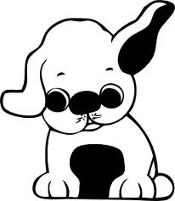
“Ouch”: Used to express pain.
Example: You stepped on my toe! Ouch, that Hurt!

Are the following “Aww” or “Ouch” moments.

- _________ kilo-puppies _________ mili-puppy
- _________ centi-ipod _________ hecto-ipod
- _________ kilo-papercuts _________ centi-papercut
- _________ deca-babies _________ deci-baby
- _________ kilo-dollars _________ milli-dollar
- _________ deca-homework _________ deci-homework

Come up with 2 more!
- _________
- _________

Aww or Ouch Name: _____________________________________________ Date: _______ Period: _____
“Aww”: Used to express a sentimental reaction to warm fuzzy experiences
Example: Aww…that kid hugging the bear is so cute!
“Ouch”: Used to express pain.
Example: You stepped on my toe! Ouch, that Hurt!

Are the following “Aww” or “Ouch” moments.

- _________ kilo-puppies _________ mili-puppy
- _________ centi-ipod _________ hecto-ipod
- _________ kilo-papercuts _________ centi-papercut
- _________ deca-babies _________ deci-baby
- _________ kilo-dollars _________ milli-dollar
- _________ deca-homework _________ deci-homework

Come up with 2 more!
- _________
- _________

