Asking your own Questions for Better Learning!
QFT
Ground Rules:
- Ask as many questions as you can.
- Do not stop to discuss, judge, or answer the questions.
- Write down every question exactly as stated.
- Change any statement into a question.
Step 1: Select a Scribe
Our group’s scribe is: _______________________________
When prompted, begin asking questions. Be sure to share questions slowly (the scribe can only write so fast!) so that all questions are captured verbatim. Don’t forget to number your questions!
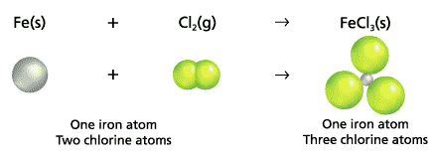
Q-Focus

Step 2:Categorizing Questions
Level 1 | Specific Information that can be found directly in the text.  One word, Yes/No answers, Copy/Paste answers
Level 2 | Answer implied in the text by finding information for the answer in several places.
Level 3 | Answers based on experiences and opinions that are supported by textual facts.

Step 3: Improving Questions
Look over your list of questions and select three (3) questions to “bump up”
Change a level 1 or 2 to a 3. (Continue your numbering with these questions).

Step 4: Prioritizing Questions
Choose the two most important questions from your list.
Keep this in mind when selecting your questions:
- Name of Unit 4 = Balancing Moles
- We’re going to be learning about balancing chemical equations.
Step 5: Share your Questions
Please share:
- Two (2) priority questions
- Rationale for selecting those questions.
- The numbers of your priority questions.
- Question Level
Step 6: Written Participant Reflection
Comparing the first time we did QFT to this time, how do you feel about your ability to come up with your own questions?

Please write down one higher level thinking question you have about balancing equations.

