Dimensional Analysis Air Canada-Flight 143-Fill-in Notes Chemistry/Math
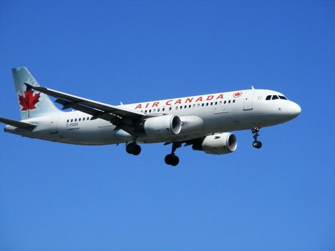
- Take GREAT notes as we work through this PowerPoint. These notes will become an effective study tool for you to refer to as you master the skill of solving dimensional analysis problems!
- Keep these notes for reference. You MAY be allowed to use them on a quiz in the future !
- Dimensional Analysis means to ___________________________________________
_____________________________________________________________________.
- In this case, what was the physical object to be analyzed? ______________________.
- The Problem: The fuel measurement for Flight 143 should have been from a volume measurement of Liters to a mass measurement of _________________. This would have been a metric conversion of volume to mass within the same system of measurement.
- What happened? The fuel attendant converted volume of fuel in Liters to an English (Imperial) system of _____________.
- The Boeing 767 aircraft needed ______________kilograms (kg) of fuel but the plane left the airport with _____________ pounds (lbs.) of fuel.
This was a BIG mistake in kilograms of fuel. Follow the steps below to determine how many kilograms of fuel were actually put into the jet:
- What are the five steps to solving a dimensional analysis problem?
  - Step #1-___________________________________________________
  - Step #2-___________________________________________________
  - Step #3-___________________________________________________
  - Step #4-___________________________________________________
  - Step #5-___________________________________________________
Use dimensional analysis to find the amount of fuel that was pumped into the jet’s fuel tanks. Write the equation in the space below:

- What answer do you get? How many kilograms of fuel were in the jet’s fuel tanks?______________________________________________________
- How much more fuel did they need in kilograms?________________________________
PRACTICE PROBLEM
- A fuel attendant’s tanker truck measures fuel by volume. She knows that the jet needs 25,000 kg of fuel. There are 0.81 kg in every “1” liter of jet fuel. How many liters of fuel will she be pumping into the jet? (write the full set up in the space below)

- What if the fuel attendant made the same mistake that the attendant did with Air Canada Flight 143? If she converted the 25,000 kg of fuel that her jet needed using a conversion for pounds instead of for kilograms then how many liters of fuel would she have put in the jet’s tanks? There are 1.78 lbs for every 1 liter of jet fuel. (write the set up in the space below-Show the mistake that she made-Having trouble with finding units to cancel?)

- How should this equation look in order to be correct? (write this out in the space below)

______________________________________________________________________________
!!!!CONTEST TIME!!!
Time to practice your new D.A. skills “1” problem at a time!
#1) Four students want to take a road trip but they have limited funds. Genny’s car holds 4 people and gets 35 miles per gallon (mpg). They want to go to San Francisco for the day. The distance for them is 180 miles one way and fuel is $4.25/gallon. How much money would each student have to pitch in order for them to make it to San Francisco and back home again? (show your work in the space below)

#2) Mrs. Dibble was just beginning to teach her student’s about moles. She explained that a mole is a counting number, like a dozen, but much bigger! The mole is 6.02 x 10²³ particles. If a person masses out the correct molar mass in grams for a substance then she would have an entire mole of it. If the molar mass for H₂O is 18 g and Mrs. Dibble had 36 grams of H₂O then how many molecules did she have? (show your work in the space below)

#3) Dr. LaHue had a canine patient that weighed 70 kg. The rather large dog needed some antibiotics and the dosage was 4 mg./kg. How many milligrams (mg) should Dr. LaHue give his patient? (show your work in the space below)

#4) Martha wanted to several boxes of shirts for the men in her family. The shirts were $29./box and there were 5 shirts per box. Each shirt sold separately for $6.25. How much would Martha pay for each shirt if she bought them by the box? Which is the better deal, to buy the shirts individually or to buy them by the box? (show your work in the space below)

#5) Shaun wanted to borrow a cup of sugar from his neighbor. He was studying the chemical mole in class and knew that his neighbor was a chemistry professor so thought that he’d impress him by showing him how many moles of sugar he’d be borrowing. The molar mass for table sugar is 342 grams/mole. There are 200 g of sugar in a cup. How many mole’s of sugar would he get if he borrowed one cup? Would he get a full mole? (show your work in the space below)

MOLAR MASS
Where did the 342 grams for sucrose come from? Do you remember how to find molar mass? Try this right now using the space provided below. (HINT: use the Periodic Table of Elements)

!!!HOMEWORK REMINDER!!

- Using the Internet as your resource, find at least 2 catastrophe’s that have occurred because of an error in Dimensional Analysis.
- Show your resources.
- Write a clear, brief summary explaining and/or describing the catastrophe and in what way that dimensional analysis was involved in the error.
- Be prepared to share your homework in class on ___________.

