Last Name, First Name: __________________________________________________________ Date: _____________________________ Period: ____
A Chemist’s Favorite Tree Screencast Notes
NGSS Standard Assessed: HS-PS1-7. Use mathematical representations to support the claim that atoms, and therefore mass, are conserved during a chemical reaction.
Essential Questions:
- What is chemical stoichiometry?
- What are the 3 basic steps of dimensional analysis?
- How do you know what to round your answers to?
- How do you know the molar mass of a chemical? What is the molar mass of CaCl₂?
- How do you convert 63 g of CaCl₂ to moles of CaCl₂? (please show work)
Thinking Side Main Notes Side
What is a chemist’s fave tree? _____________________________
What is stoichiometry? The best definition for stoichiometry is this:
It’s a way of figuring out how much ________________________________________________________
or how much _________________________________________________________________________________
Peanut butter and jelly ex:
Think of it in terms of peanut butter and jelly sandwiches…
Please: Use this space to draw the PB and J example

Quick Dimensional Analysis
Re-cap: Purpose: ______________________________________________________________________________________

________________________________________________________________________________________________.
In chemistry lab, we don’t have a _________-___-_______ so we can only take chemical
measurements in _____________ ( ) or _____________ ( ).

What’s a conversion? ________________________________________________________________________________________________.
An example:

What are conversion factors? ____________________________________________________________

____________________________________________________________

____________________________________________________________
An example from the above
conversion:

Criss Cross Applesauce: _________________________________________________________________________________________________

_________________________________________________________________________________________________

_________________________________________________________________________________________________
An example: You need to know how many particles there are 10 moles of a substance.

Which conversion factors are
the same no matter what _________________________________________________________________________________________________
chemical you have?

What is the conversion for L?

Molar Mass: _________________________________________________________________________________________________
What is molar mass?

How do you know the molar
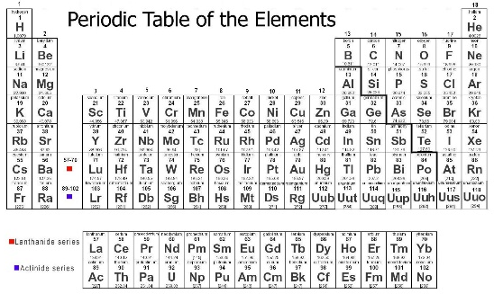
mass of a substance?

All masses on the periodic table are in grams for 1 mole of each substance!

What is the conversion for
grams of K to moles of K?

How do I know what to round to?

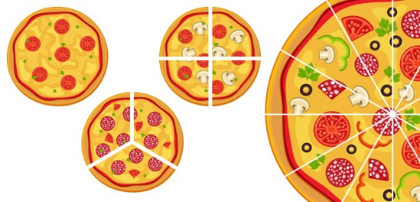
Important DA note: Please label the pizza pieces with the fraction of the whole they represent:
Please write our fraction mantra:

Summary: (please answer the essential questions in this section)

